**Experiment :-**

**Design a system that automatically turns on the lights inside an almirah whenever it is opened, (irrespective of day/night)**

**Circuit Diagram:-**

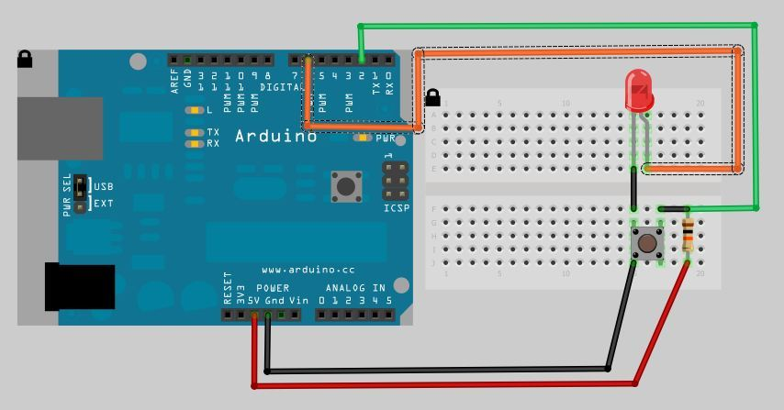

**Theory:-**

**Concept Used:-**

The concepts used while doing this experiment are:-

* The arduino board can supply a power of 5V as digital output signals through the 14 pins.
* The GND pin of the arduino board acts as ground.
* In the bread board present in the above circuit diagram the two rows present at the top and bottom each, are connected with each other in series and the columns present in between are connected in a set of 5 each. The connection pattern is shown below: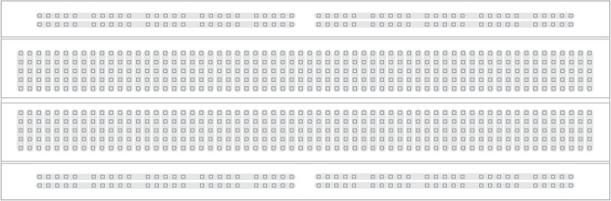
* Kirchoff’s current law:-Total current that is flowing in a junction is equal to current flowing out of that junction.
* Ohm’s Law:-Ohm’s law states that the current through a conductor is directly proportional to the voltage across the two points provided that the physical conditions remains constant.

V=IR

**Learning Outcomes:-**

* I have learned how to make circuits practically by using Arduino board.
* I have learned how all the hardwares should be connected to make them work in a proper condition.

**Problems and Troubleshooting:-**

The problems faced by me while doing this task are :-

* The LED which I used was not in a proper working condition.
* The circuit was not working because the wires were not connected properly.

**Precautions:-**

The precautions that should be taken while doing this experiment are:-

* The connections should not be loose.
* Every stuff should be joined at their appropriate place and it should be properly closed.
* The code should be written properly.

**Learning and Observation:-**

**Learnings:-**

* I have learned how to work practically with a breadboard and other things.
* I have learned how an arduino works and how current flows.
* I have learned how to use arduino circuits in daily life problems.

**Observations:-**

According to the question, The Red LED will glow whenever te increase volume button is pressed,a red LED blinks the number of times the button is pressed.